CYB 300 Module Three Lab Worksheet One

Andree Salvo
Southern New Hampshire University
CYB 300
Instructor: Jason Keltner

Lab: Cryptographic Solutions

Exercise 1: Create and Verify a Digital Signature
Prompt | Response
Task 1: Take a screenshot of Step 8 showing successful completion of public and private key pair. Add your name in the command line. | 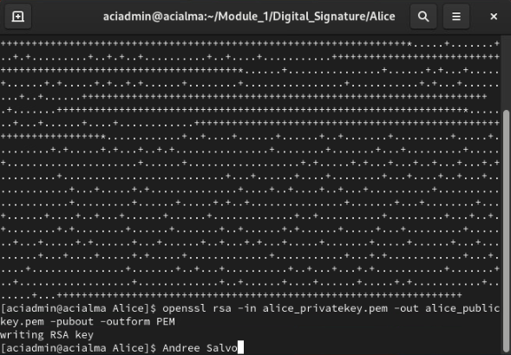

Exercise 2: Create and Approve a Certificate Signing Request
Prompt | Response
Task 2: Take a screenshot of Step 8 showing the receipt confirmation of three certificate-related files. Add your name in the command line. | 